Chapter 10, Problem 22.

For the circuit in Fig. 10.71, determine V_{o}/V_{s}.

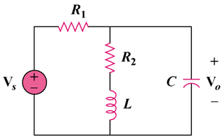

Figure 10.71
For Prob. 10.22.

